The most important initial task in designing a DSL or policy framework has nothing to do with operators, macros or any of the facilities of Star — you must identify the appropriate structure and semantics for your language. More formally, this can be defined as identifying the ontology of the language.
Ontology, as a discipline, dates back to Aristotle. He was one of the first people to attempt to systematically classify the known world. Nowadays, Ontology refers to the study of the relationship between concepts and the real world.
<$Scr_Ps::0>Ontology
<!$Scr_Ps::0><$Scr_Ps::1>A description of a set of concepts and how they relate to each other and to the intended domain.
<!$Scr_Ps::1>A systematic, or formal, ontology is often written in a language that allows automated verification of desirable aspects of the ontology — such as its consistency.
Developing an ontology often starts by brainstorming a set of words that seem to be important in the domain. For example, an ontology of pet animals would include the concepts of Dog, Cat, Giraffe and so on. It would likely also include the concepts of caring for a pet and of breeding them.
Our RDF triple language also has an ontology — about the concepts involved in knowledge graphs. The figure below shows such a collection, which, while it is not the complete set needed for conceptualizing triple graphs, makes a good start:
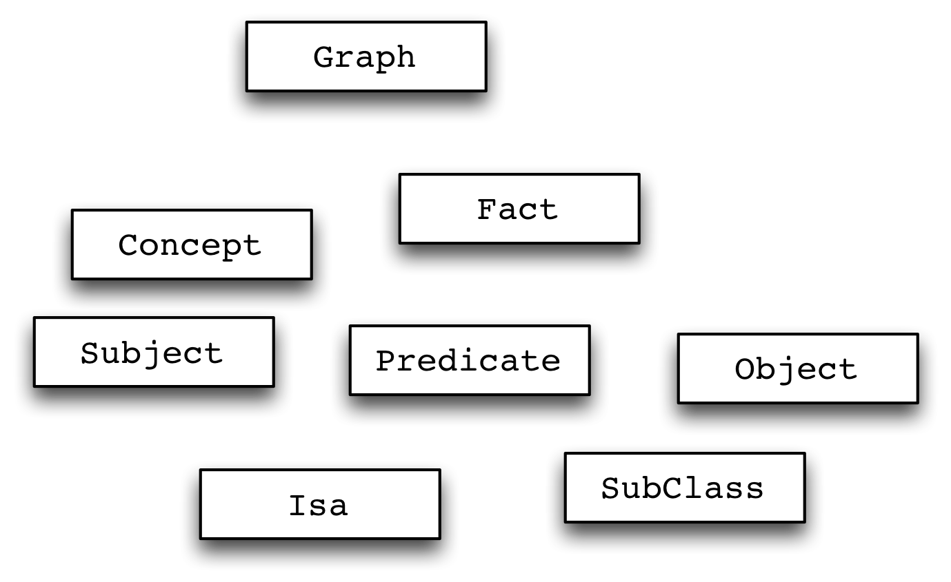
<$Scr_Ps::2>A Collection of Concepts Important to Triple Graphs
<!$Scr_Ps::2>Once you have a set of concepts it helps to organize them. Common meta-concepts in ontologies include the notions of class, instance, and the sub-class relationship — not to be confused with similar concepts in Object Oriented Programming. For example, your giraffe Joe denotes an instance of the Giraffe class, and Giraffes are a sub-class of the more general concept of Pet.
One simple (sometimes simplistic) tool for figuring out an ontology is UML. UML has the great advantage of being very visual and therefore can often be useful in bringing out the salient parts of an ontology. For example, a UML diagram of our triple graph conceptualization highlighting some of the important classes and their relationships can be seen in:
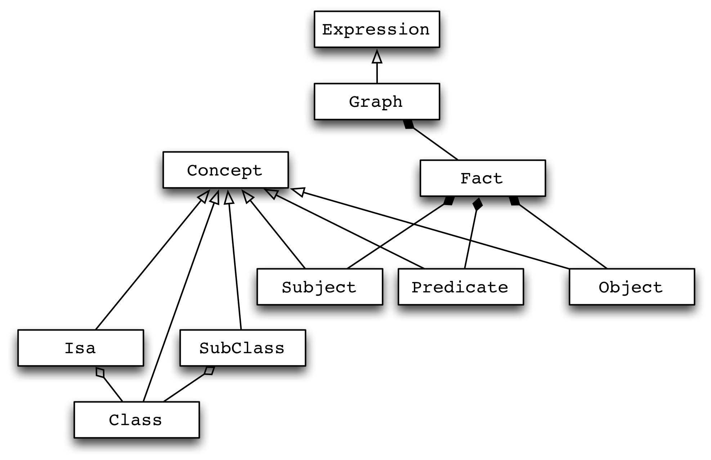
<$Scr_Ps::2>UML Diagram of Triple Graph Ontology
<!$Scr_Ps::2>The role of the UML diagram is to make it clear what the key features and components of your language are — so you don’t miss anything important.
The careful reader will notice that we have actually extended the ontology to include the concepts of class, cub-class and instance; which are actually part of RDFS more than basic RDF.

